**Practical No:1**

**Program:**

import RPi.GPIO as GPIO import time

# Setup GPIO GPIO.setwarnings(False) TRIG = 11

ECHO = 8

servoPIN = 18 GPIO.setmode(GPIO.BCM)

# Ultrasonic sensor pin initialization GPIO.setup(TRIG, GPIO.OUT)

GPIO.setup(ECHO, GPIO.IN) # Corrected line: Set ECHO pin as input # Servo motor pin initialization

GPIO.setup(servoPIN, GPIO.OUT) servo = GPIO.PWM(servoPIN, 50) servo.start(2.5)

try:

while True: GPIO.output(TRIG, False)

time.sleep(0.000002) GPIO.output(TRIG, True) time.sleep(0.00001) GPIO.output(TRIG, False) startTime = time.time()

stopTime = time.time()

while GPIO.input(ECHO) == 0:

startTime = time.time()

while GPIO.input(ECHO) == 1:

stopTime = time.time() GPIO.output(TRIG, True) timeElapsed = stopTime - startTime distance = (timeElapsed * 34300) / 2 distance = int(distance)

print("Distance: {} cm".format(distance)) if distance <= 20:

duty_cycle = 12.5 # Adjust this value for desired servo position servo.ChangeDutyCycle(duty_cycle)

print("Motor Rotated") time.sleep(0.1)

else:

duty_cycle = 2.5 # Adjust this value for desired servo position servo.ChangeDutyCycle(duty_cycle)

print("Motor is at orignal position") time.sleep(0.1)

except KeyboardInterrupt: servo.stop()

GPIO.cleanup()

**Hardware Connection:**

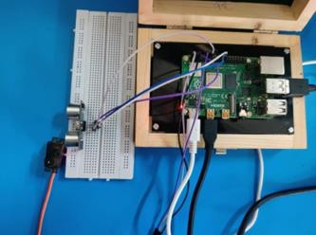

**Output:**

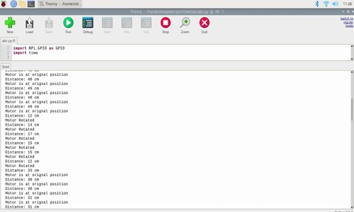

**Practical No:3**

**Program:**

import RPi.GPIO as GPIO import time

#GPIO SETUP

channel =4

GPIO.setmode (GPIO.BCM) GPIO.setup(channel, GPIO.IN) def callback (channel):

if GPIO.input (channel):

print("Water detected!") else:

print("water not detected!")

GPIO.add_event_detect (channel, GPIO. BOTH, bouncetime=300) GPIO.add_event_callback(channel, callback)

while True: time.sleep(0)

**Hardware Connection:**

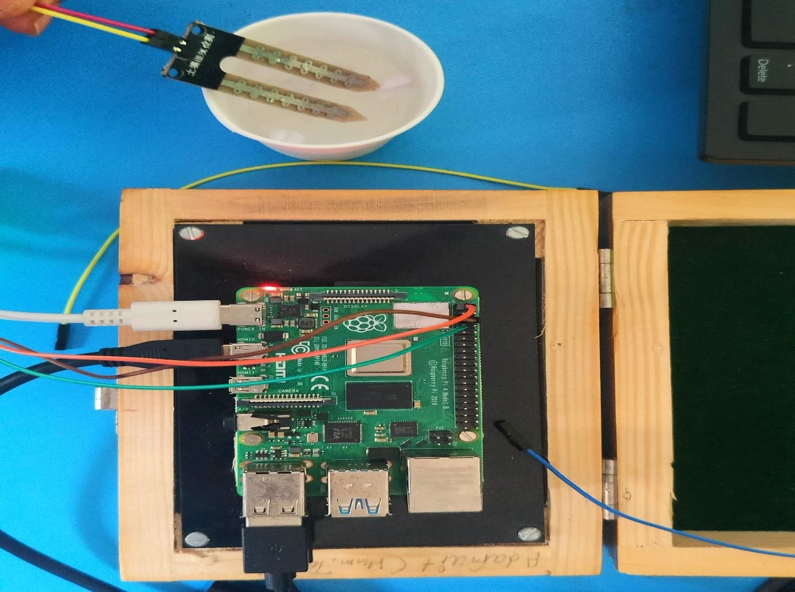

**Output:**

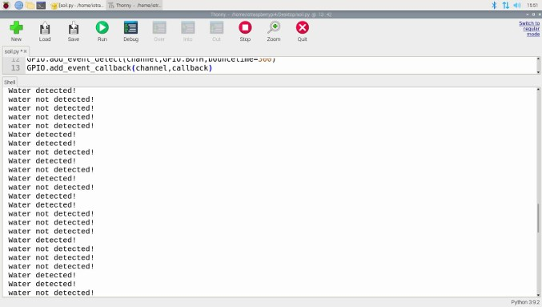

**Practical No :4**

**Program code:**

from gpiozero import LED import time

R=LED(16) Y=LED(18) G=LED(17)

while(1) :

R.on() time.sleep(3) R.off()

Y.on() time.sleep(2) Y.off()

G.on() time.sleep(3) G.off()

**Hardware Connection/output:**

